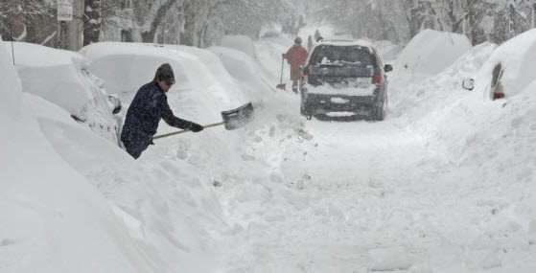

**when’s the last time fire, police, EMS, EMD, dPW , Board of Selectmen, Board of Health, park & School trained together?**

**Emergency Response Consulting is presenting an in-depth, comprehensive presentation intended to redirect emergency responders and planners on how they currently think about things and who they involve.**

**Regardless if you are an emergency responder, emergency management planner, board member, employee or citizen in the community this presentation will get you thinking and get you involved with how things work in your community.**

**Where: Rowe Elementary School**

**When: January 21, 2019**

**Time: 6 PM**

**No Charge**

Have you lead with these thoughts:

* Response Integration
* What if it’s me
* Who’s Who in the Zoo
* Did my Title Cloud my Brain
* Did I plan for Me or Them?

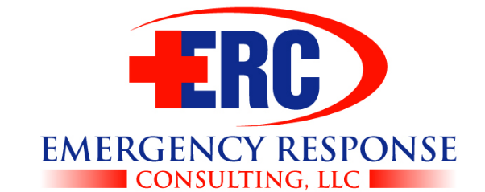

Ego’s & Attitudes:

Planning for a disaster or disaster planning?